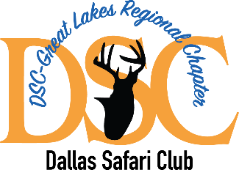
DSC – Great Lakes Regional Chapter Membership application
Name ______________________________

Street Address ___________________________________

City __________________ State _______________ Zip Code __________

Phone _______________________ Email Address _____________________________

Current DSC – Great Lakes Reginal Chapter Sponsor ________________________________

Are you a current member of Dallas Safari Club? Yes ______ No _____

Are you a current member of any other wildlife/conservation organizations? Yes ___ No ___
If yes, please identify those organizations.

Are you now, or have you within the last five years, served in a leadership position with another wildlife/conservation organization? Yes ______ No ______
If yes, please identify those organizations.

Have you ever been charged with a wildlife violation or found to have been in violation of ethical standards of any wildlife organization? Yes ______ No ____
If yes, please identify the specific organization/s.

Have you ever resigned from a wildlife/conservation organization to avoid potential disciplinary action for any reason? Yes ____ No ____
If yes, please identify the specific organization.

Chapter Membership Status requested: One year Member only _____ ($50)
One year Member and Spouse _____ ($75)
Three years Member only _____ ($125)
Three Year Member and Spouse ____ ($200)
Member Chapter Life _____ ($300)
Member and Spouse Chapter Life ____ ($475)

Do not send dues payment at this time. If membership is approved, you will receive an invoice from the Chapter in the amount of the respective dues for the requested membership status.

Submission of this application is an acknowledgement that the Chapter Board of Directors, and members of the Chapter Membership Committee reserve the right to approve or reject any application for membership for any reason or no reason but shall not discriminate against any applicant based on race, religion, sexual orientation, martial status, age or nationality.

Applicant Signature _____________________________________ Date ____________________

Return completed application via email to: DSCgreatlakes@hotmail.com or via U.S. mail to: DSC – Great Lakes Regional Chapter, 486 S. Ripley Blvd., PMB #118, Alpena, MI 49707

